Jordan Murtiff
Dr. Navid
Theory of Algorithms
6 September 2019
Final Exam
- [10 points] Transform and Conquer
Design a reasonably efficient algorithm for solving each of the following problems and determine its efficiency class.
  - You are given n telephone bills and m checks sent to pay the bills (n ≥ m). Assuming that telephone numbers are written on the checks, find out who failed to pay. (For simplicity, you may also assume that only one check is written for a particular bill and that it covers the bill in full.)
    - Using an efficient sorting algorithm (usually quicksort or mergesort), sort the telephone bills and sort the checks (in both cases of sorting, this has to be done with respect to their telephone numbers, which we can sort in increasing order). Next, do a merging scan of the two sorted lists by comparing the telephone numbers b_{f} and c_{g} on the current telephone bill and telephone check: if b_{f} < c_{g}, add b_{f} to the list of unpaid telephone numbers and increment f; if b_{f} > c_{g}, then only increment g; if b_{f} = c_{g} , increment both f and g. You have to stop as soon as one of the two lists becomes empty and then afterwards append all the remaining telephone numbers on the bill list (if there are any) to the list of the unpaid ones.

The time efficiency of this algorithm will be in:

O(n log(n)) + O(m log(m)) + O(n + m) = O(n log (n)) overall assuming that n ≥ m

The time efficiency is O(n log (n)) (which is the same as the best and average case of quicksort).

  - You have a file of n student records indicating each student’s number, name, home address, and date of birth. Find out the number of students from each of the 50 U.S. states.
    - Initialize the 50 state counters to zero (so have 50 counters all set to “0”). Next, look through the list of student records and for a given student record, increment the corresponding state counter.

The algorithm’s time efficiency will be in Θ(n).

  - For a given positive integer n, find the pair of integers whose sum is n and whose product is as large as possible.
    - Let “a” be one of the numbers we are looking for, the other number we are looking for is therefore the value of n – a. If we think about this problem graphically (in terms of finding the max of f(a) = a(n-a) on the set of all integer values of x we get the graph of:

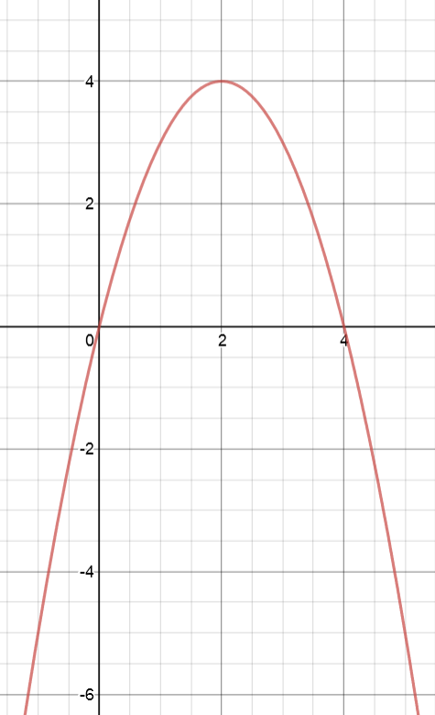
With n having a value of (4) → n can whatever value it chooses to be (n = 4 is only an example for this graph in this case).
Graph made by Desmos: https://www.desmos.com/calculator

Since the graph of f(a) = a(n − a) is a parabola with the maximum point at a = n/2, the solution is n/2 if n is even and floor(n/2) [or even ceiling(n/2)] if n is odd. Therefore, the pair of integers that we are looking for can be found as floor(n/2) and n – ceiling(n/2), which works for any parity of n (even or odd numbers).

The algorithm’s time efficiency should only take Θ(1). The division of 2 in either of the formulas shouldn’t take very long even with large values of “n”.

  - How many one-digit additions are made by the pen-and-pencil algorithm in multiplying two n-digit integers? (You may disregard potential carries.)
    - Let i and j be two n-digit integers so that the product of each pair of their digits is a one digit number. Then the result of the pen-and-pencil algorithm will look kind of like this:

Given our two integers of i and j → with each multiplication each digit of i is multiplied by each digit of j, we have pairs of each of these values:

i: i_{n-1} … → i₁ i₀
j: j_{n-1} … → j₁ j₀
d_{n-1}, ₀ … → d_{1, 0} d_{0, 0}
d_{n-1, 1} d_{n-2}, ₁ → d_{0,1}

So the different digits will multiply and we have d_{1, 0}, d_{0, 0}, and d_{0,1} for all the possible different digits.

So the number of additions should be some sort of series:

d_{n-1}, _{n-1} → 0 (n-1 ● n-1 digit)
d_{n-2}, _{n-1} → 1 (n-2 ● n-2 digit)
d_{1, n-1} → n – 2 (digit 1 ● n-1)
d_{0, n-1} → n – 1 (digit 0 ● n-1)
… → 0 and 1 (the last few cases of the series)

0 + 1 + … n – 2 + n – 1 + … 1 + 0

So if we simplify the series we get:

1 + 2 + … + (n – 1) + (n – 2) + … + 1 =

[1+ 2 + … + (n – 1)] + [(n – 2) + … + 1] =

[(n – 1)● n]/2 + [(n – 2)(n – 1)]/2 = (n – 1)²

So the number of one-digit addictions made by the pen-and-pencil algorithm in multiplying two n-digit integers is (n – 1)² (while disregarding potential caries)

- [9 points] Input Enhancement and Pre-structuring
  - There are ten Egyptian stone statutes standing in a row in an art gallery hall. A new curator wants to move them so that the statues are ordered by their height. How should this be done to minimize the total distance that the statues are moved?
    - For each and every one of the 10 statues count the total number of statues shorter than it (which can be done by some comparison counting sort) and then use these counts to move each of the statues from their current positions with (i = 0, 1, …, 9) to their target positions Statue[0], Statue[1], …, Statue[9] (so for the statue that is the shortest [it is taller than 0 of the statues], it moves into Statue[0] position, and for the statue that is taller than the rest of the statues it moves into the Statue[9] position, since that statue is taller than the other 9 statues). Since every statue is moved into its final position directly, the algorithm can minimize the total distance that the statues are moved.
  - The birthday paradox asks how many people should be in a room so that the chances are better than even that two of them will have the same birthday (month and day). Find the quite unexpected answer to this problem. What implication for hashing does this result have?
    - I’m assuming that better than even means better than 50% or ½:
If we compare one person in a room to another, there should be a 364/365 chance of failure (meaning that the person does not have the same birthday as the other person). In other words, there is a 364/365 = 99.726027% chance that the two people in the room (assuming that n = 2 in this case) do not have the same day and month as their birthdays. So how many comparisons (or people) does it take so that we have a 50% or above chance that two people in the room have the same birthday?

Example cases:
2 people → 1 comparison
3 people → 3 comparisons
4 people → 3 + 2 + 1 = 5 comparisons
…
30 people → 29 + 28 + 27 + … + 1 = Σ n = 1 to 29 of (n) = 435 comparisons

We know that the chance of failure for each is 99.726027%, so for 30 people in a given room (n = 30) we should have (364/365)⁴³⁵ = 30.318317% chance that there will not be two people that have the same birthday in a room of 30 people. This means that there will be a 100% – 30.318317% = 69.681683% chance that there are two people in the room that have the same birthday month and day.

Our number of people was too high, so we should lower it to 20 instead:
20 people → 19 + 18 + 17 + … + 1 = Σ n = 1 to 18 of (n) = 190 comparisons

We know that the chance of failure for each is 99.726027%, so for 20 people in a given room (n = 20) we should have (364/365)¹⁹⁰ = 59.377009%‬ chance that there will not be two people that have the same birthday in a room of 20 people. This means that there will be a 100% – 59.377009% = 40.622991% chance that there are two people in the room that have the same birthday month and day.

Our number was too low, so we should up it to 23 instead (since 23 is about half way to 25 and we are kind of close to 50% being only at 59.3% with our previous answer).

23 people → 22 + 21 + 20 + … + 1 = Σ n = 1 to 22 of (n) = 253 comparisons

We know that the chance of failure for each is 99.726027%, so for 23 people in a given room (n = 23) we should have (364/365)²⁵³ = 49.952234%‬ chance that there will not be two people that have the same birthday in a room of 20 people. This means that there will be a 100% – 49.952234% = 50.377009% chance that there are two people in the room that have the same birthday month and day.

If we lower our number to 22 or up our number to 24 we will get either below 50% or above 50% even more. So sticking with n = 23 people will be our final answer.

The implication for hashing is that we should expect collisions even if the size of a hash table is much larger (possibly by more than a factor of 10 times) than the number of keys we include.
  - Outline an algorithm for finding the largest key in a B-tree
    - Starting at the root of the B-tree, follow the chain of the rightmost pointers (keep going to the right of the tree) to the (rightmost) leaf. The largest key is the last key in that given leaf. The rightmost key in the rightmost leaf of a B-Tree will always be the biggest element of that given B-Tree.

- [5 points] Dynamic Programming
  - How would you modify the dynamic programming algorithm for the coin collecting problem if some cells on the board are inaccessible for the robot? Apply your algorithm to the board below, where the inaccessible cells are shown by X’s. How many optimal paths are there for this board?
    - We know for this problem we have this formula:

F(i, j) = the cell at the bottommost row and furthest column

F(i, j) = max{F(i − 1, j ), F(i, j − 1)} + c_{ij} for the cases of 1≤ i ≤ n, 1≤ j ≤ m (find the max of a given cell, since we can either move one cell to the right or one cell down).

F(0, j) = 0 for 1≤ j ≤ m and also F(i, 0) = 0 for 1≤ i ≤ n (we know that for the “zeroth” row and column that there are no coins above the robot (since above the first row is nothing) and no coins to the left of the robot (since to the left of the first column is nothing as well), so we have to assume these two special cases and mark that for the “zeroth” row and the “zeroth” column, that there are 0 coins in each of these spaces. This isn’t really used in this problem as there is no “zeroth” row or column to be marked, but in general, this is still true.

Now we can just change the above formulas to fit for this new situation for inaccessible spaces:

If a cell is inaccessible (or has no accessible neighbors above or to the left of the cell) then that cell is marked as inaccessible (if it hasn’t already been marked as such already) and no value is computed for that cell (since you can’t access the cell, no point in giving it a value at all). If a cell has just one admissible neighbor above or to the left of it, then that value is used with the formula above (F(i, j) = max{F(i − 1, j ), F(i, j − 1)} + c_{ij} for the cases of 1≤ i ≤ n, 1≤ j ≤ m), otherwise, the algorithm just continues to fill in each of the spaces of the table as it would by just following the above formula with no need to worry about inaccessible cells.

So the only changes that is really put in is the part of inaccessible neighbors → it a cell is inaccessible (or has no accessible neighbors to the left or above it) then the cell is marked as inaccessible (by some variable), HOWEVER, is a cell can be accessed (by a cell above or to the left of it), then use the value in that cell above or to the left to calculate the value of the formula for finding the max of F(i, j) for the given row and column. If there are no nearby inaccessible cells, then calculate the value of the cell normally without any worry of inaccessible cells.

Apply the algorithm to the given problem:
All cells marked with “N/A” are not accessible by the robot.
Each cell either has “N/A” or the given number of coins for that path.
The highest number of coins the robot can get is 4.
 | 1 | 2 | 3 | 4 | 5 | 6
1 | 0 | N/A | N/A | N/A | N/A | N/A
2 | 1 | 1 | 1 | N/A | N/A | N/A
3 | 1 | 2 | 2 | N/A | N/A | N/A
4 | 1 | 2 | 2 | 3 | 3 | 4
5 | N/A | N/A | N/A | 3 | 4 | 4

Diagram of all possible paths:
Main paths are black lines and alternate paths are in orange lines with “X” marking the areas that are not accessible by the robot:
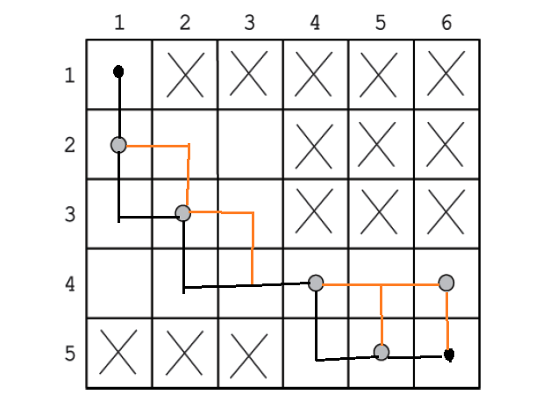
There are 12 different paths for the robot to get all the maximum 4 coins possible.

- [5 points] Greedy Algorithm
  - Construct a Huffman code for the following data:
Symbol | A | L | I | Z | P
Frequency | 4.5 | 0.5 | 3.0 | 1.0 | 1.0

Step 1:
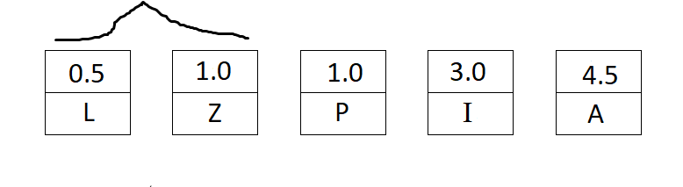
Step 2:
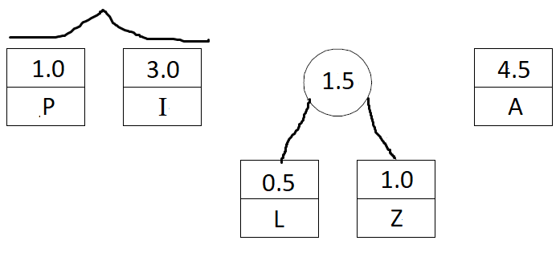

Step 3:
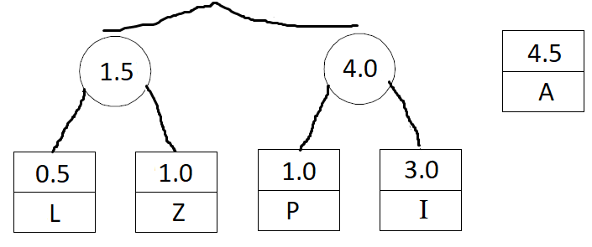

Step 4:
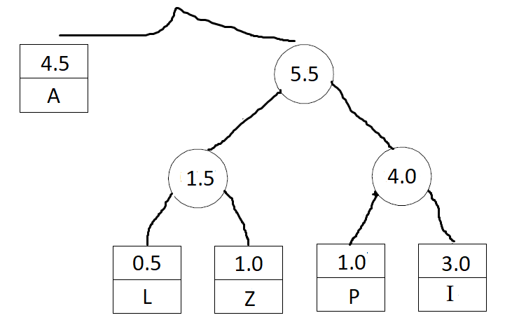

Step 5:
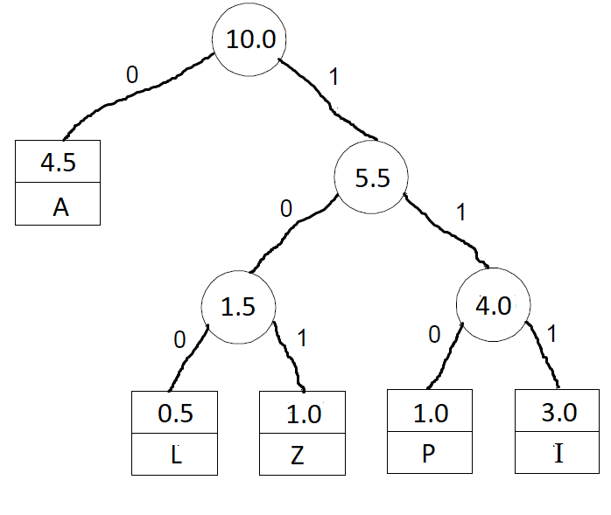
Above is the final Huffman code/tree:
A → 0
L → 100
Z → 101
P → 110
I → 111

  - Encode PLAZA using the code of part (a).
    - PLAZA
P = 110
L = 100
A = 0
Z = 101
A = 0

110 100 0 101 0

PLAZA = 11010001010

  - Decode 10011101110110 using the code of part (a).
    - 100 → L
111 → I
0 → A
111 → I
0 → A
110 → P

10011101110110 = LIAIAP
- [1 point] P vs. NP
  - Which of the following diagrams do not contradict the current state of our knowledge about the complexity classes P, NP, and NPC (NP- complete problems)? Explain briefly.
    - Diagram A is impossible due to the fact that the trivial decision problem (whose solution is “yes” for all inputs) is not NPC (not NP-complete).
    - Diagram B is possible since it depicts the case of P = NP.
    - Diagram C is impossible because it implies the existence of an NPC (NP-complete problem) that is in P, which therefore requires that P = NP.
- Diagram D is possible since it depicts the case of P ≠ NP.

- [5 points] Decision Trees
  - Draw a decision tree and find the number of key comparisons in the worst and average cases for the three-element enhanced bubble sort (which stops if no swaps have been made on its last pass).
Final Decision Tree:
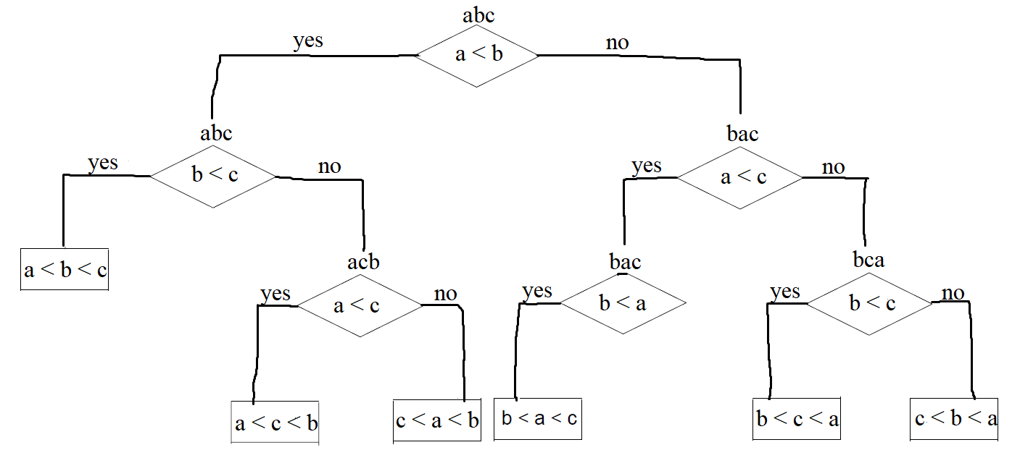

Number of key comparisons:

Worst case: Three (3) comparisons (only takes a maximum of three comparisons to get to the bottom of the tree).

Average Case: Take each path and add the number of comparisons together and divide by the total number of paths:

(2 + 3 + 3 + 3 + 3 + 3)/6 = 2 + 5/6 = 2.833333333 comparisons in the average case

- [5 points] Backtracking
  - Apply backtracking to the problem of finding a Hamiltonian circuit in the graph below:
    - Let’s create the state-space tree step by step (each step was done until you got the final state-space tree at the end of the solution). For each step the node being refrenced in the beginning of the step (with the exception of back-tracking steps) is the node that is being added on to.
So for example, when node “b” is talked about, when you add node “d” to the state-space tree, that means add node “d” connected to node “b”.

- Select “a” as root node. Add “a” as the root node of the state-space tree.
- Select the adjacent nodes of “a” in alphabetical order. The adjacent nodes of “a” are {b, c, d}. Pick first adjacent node and add node “b” to the state-space tree connected to node “a”.
- Select the adjacent nodes of “b” in alphabetical order. The adjacent nodes of “b” apart from {a} are also {d, e, g}. Pick first adjacent node and so add node “d” to the state-space tree connected to node “b”.
- Select the adjacent nodes of “d” in alphabetical order. The adjacent nodes of “d” apart from {a, b} are also {f, g}. Pick first adjacent node and so add node “f” to the state-space tree connected to node “d”.
- Select the adjacent nodes of “f” in alphabetical order. The adjacent nodes of “f” apart from {a, b, d} are also {c, g}. Pick first adjacent node and so add node “c” to the state-space tree connected to node “f”.
- Select the adjacent nodes of “c” in alphabetical order. The adjacent nodes of “c” apart from {a, b, d, f} are also {}. Since all the nodes are not visited in this tree, this is considered a dead end.
- Backtrack from node “c” to node “f”. Select the adjacent nodes of “f” which are {c, g} and since “c” has already been done, add node “g” to the state-space tree connected to node “f”.
- Select the adjacent nodes of “g” in alphabetical order. The adjacent nodes of “g” apart from {a, b, d, f} are also {e}. Pick first adjacent node and add node “e” to the state-space tree connected to node “g”.
- Select the adjacent nodes of “e” in alphabetical order. The adjacent nodes of “e” apart from {a, b, d, f, g} are also {}. Since all the nodes are not visited in this tree, this is considered a dead end.
- Backtrack from node “e” to node “g”. Select the adjacent nodes of “g” which there are none and then backtrack from node “g” to node “f”.
- Try to find the adjacent nodes of node “f”, there are none apart from nodes {c, g} (which have both been used), so backtrack from node “f” to node “d”.
- Select the other adjacent nodes of “d” (so in this case it is the nodes {f, g}) and since node “f” has already been used, add node “g” to the state-space tree connected to node “d”.

The state-space tree now looks like this (state-tree being half completed):
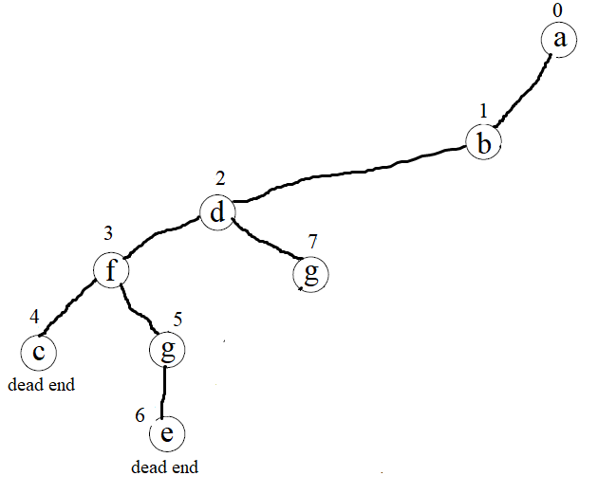
- Select the adjacent nodes of “g” in alphabetical order. The adjacent nodes of “g” apart from {a, b, d} are also {e, f}. Pick first adjacent node and add node “e” to the state-space tree connected to node “g”.
- Select the adjacent nodes of “e” in alphabetical order. The adjacent nodes of “g” apart from {a, b, d, g} are also {}. Since all the nodes are not visited in this tree, this is considered a dead end.
- Backtrack from node “e” to node “g”. Select the other adjacent nodes of “g” (which in this case is {e, f}) and since node “e” has already been used then add node “f” to the state-space tree connected to node “g”.
- Select the adjacent nodes of “f” in alphabetical order. The adjacent nodes of “f” apart from {a, b, d, g} are also {c}. Pick first adjacent node and add node “c” to the state-space tree connected to node “f”.
- Select the adjacent nodes of “c” in alphabetical order. The adjacent nodes of “c” apart from {a, b, d, g, f} are also {}. Since all the nodes are not visited in this tree, this is considered a dead end.
- Backtrack from node “c” to node “f”. Select the other adjacent nodes of “f” (so in this case it is the nodes {c}) and since no more nodes beside node “c” can be used, back track again from node “f” to node “g”.
- Select the other adjacent nodes of “g” (so in this case it is the nodes {e, f}) and since no more nodes beside nodes “e” and “f” can be connected to node “g”, back track again from node “g” to node “d”.
- Select the other adjacent nodes of “d” (so in this case it is the nodes {f, g}) and since no more nodes beside nodes “f” and “g” can be connected to node “d”, back track again from node “d” to node “b”.
- Select the other adjacent nodes of “b” (so in this case it is the nodes {d, e, g}) and since node “d” has already been used, add “e” in the state-space tree connected to node “b”.
- Select the adjacent nodes of “e” in alphabetical order. The adjacent nodes of “e” apart from {a, b} are also {g}. Pick first adjacent node and add node “g” to the state-space tree connected to node “e”.
- Select the adjacent nodes of “g” in alphabetical order. The adjacent nodes of “g” apart from {a, b, e} are also {d, f}. Pick first adjacent node and add node “d” to the state-space tree connected to node “g”.
- Select the adjacent nodes of “d” in alphabetical order. The adjacent nodes of “d” apart from {a, b, e, g} are also {f}. Pick first adjacent node and add node “f” to the state-space tree connected to node “d”.
- Select the adjacent nodes of “f” in alphabetical order. The adjacent nodes of “f” apart from {a, b, e, g, d} are also {c}. Pick first adjacent node and add node “c” to the state-space tree connected to node “f”.
- Select the adjacent nodes of “c” in alphabetical order. The adjacent nodes of “c” apart from {a, b, e, g, d, f} are also {}. And therefore since node “a” is next to node “c”, we therefore have the case where every node is visited at least once.
- Therefore the state-space tree path contains the nodes {a, b, e, g, d, f, c} and we can add the node “a” to the state-space tree.
So the final tree looks like:
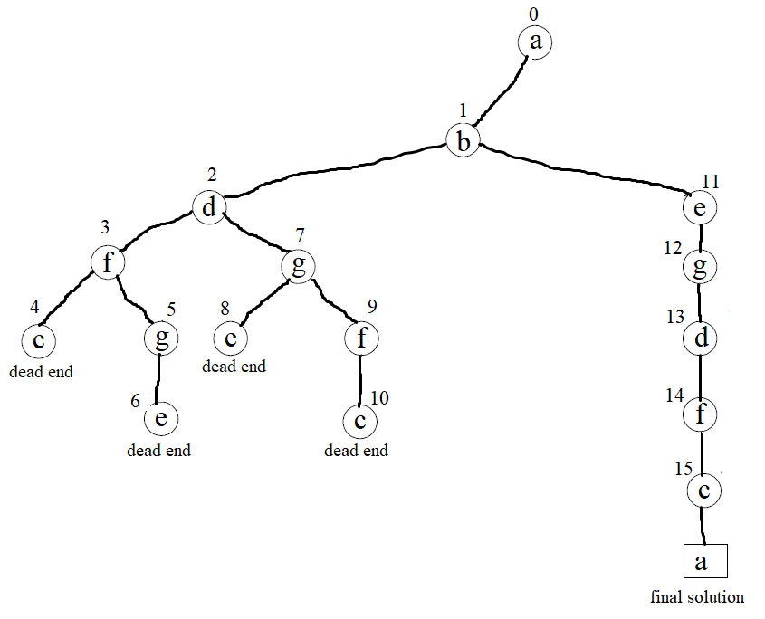
And the Hamiltonian circuit is a → b → e → g → d → f → c → a.

